**Name:** Safyan Anwar

**Roll no:** S24-018

**Section:** 3A-BSSE

**Assignment #:** 1

**Submitted to:** Sir. Rashik

**LAB # 1:**

**Code:**

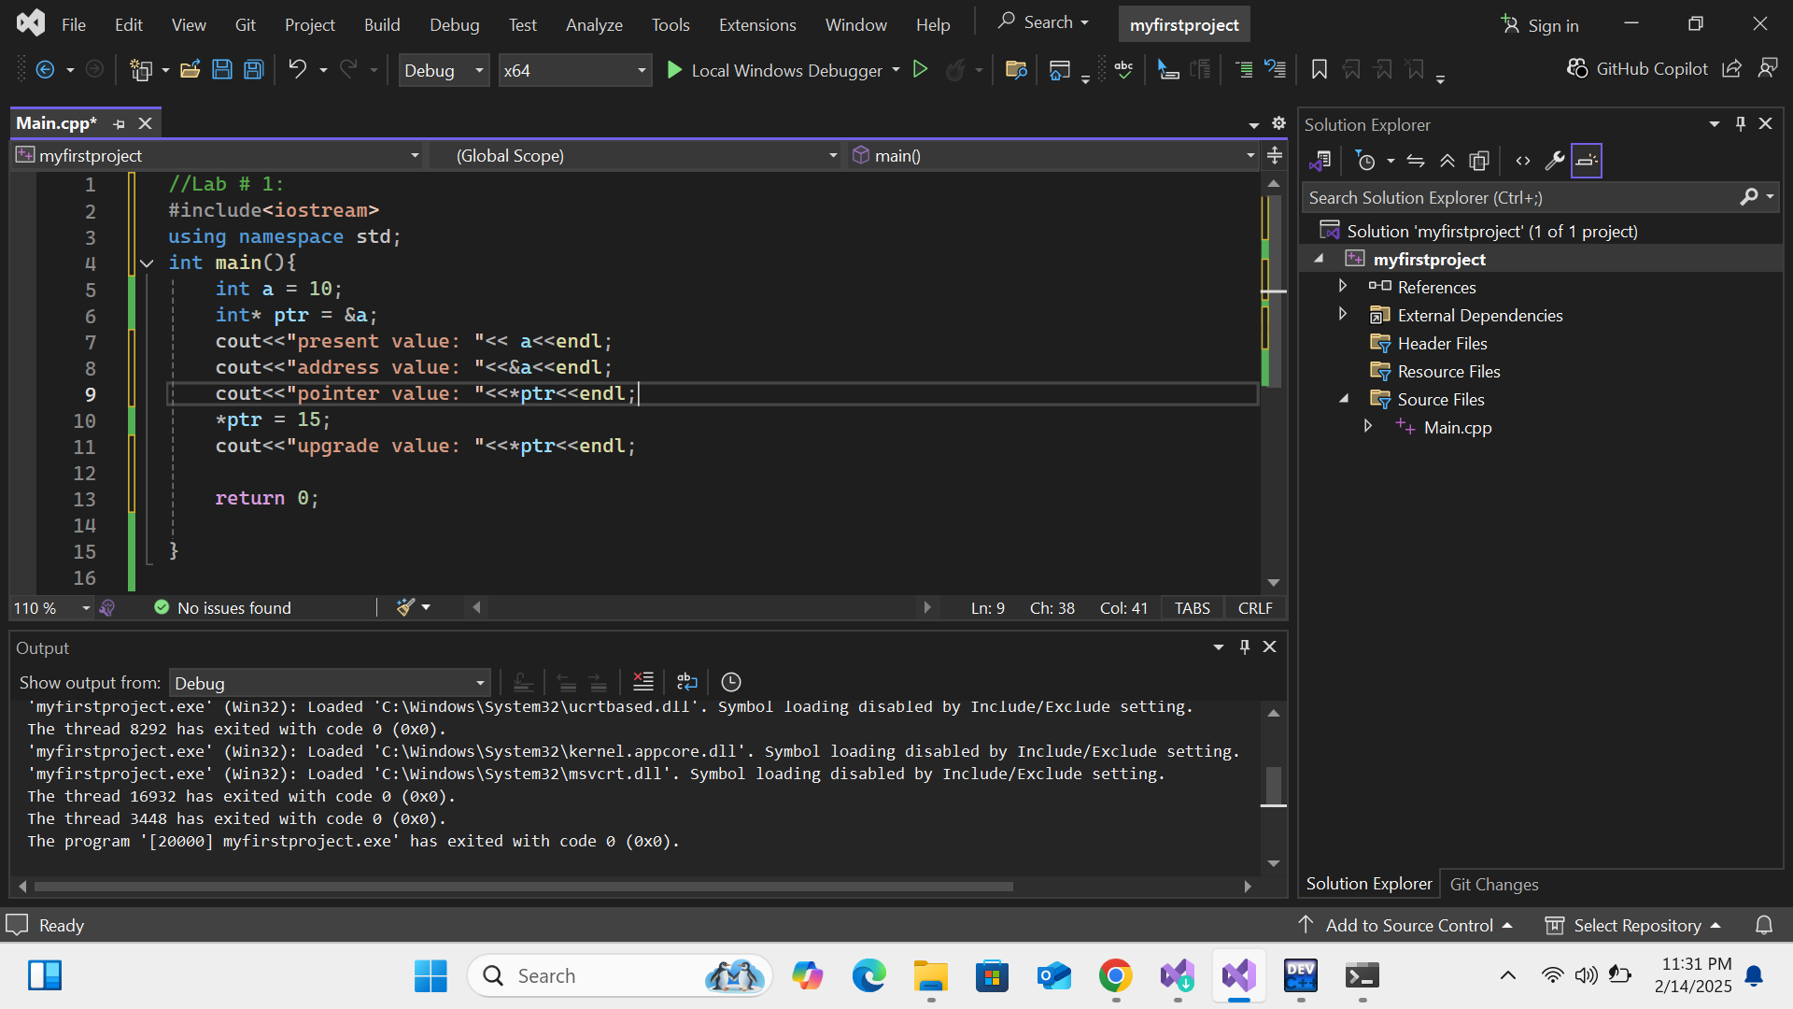

**Output:**

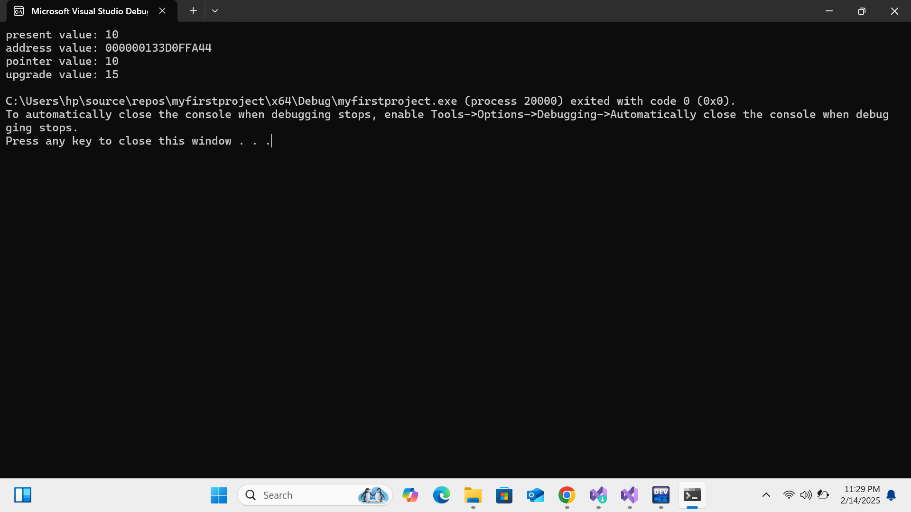

**Explanation:**

I first of all declare ‘a’ and a initialize with 10. Secondly declare ‘*ptr’ and can hold address of the integer it is initialize ‘a’ by using bitwise operator ‘&’. The ‘&a’ give a address of ‘a’. Display the values in code and upgrade the value by using pointer. Since a was updated through the pointer its will now display 15.